Izgled zavičaja i gospodarska djelatnost u zavičaju

IME I PREZIME:________________________________________________

1. Reljef čine sve _____________________, __________________________ i ________________ na Zemlji.
2. Na sjeveru i sjeveroistoku Varaždinske županije nalazi se ________________(nizinski /brežuljkasti ) kraj.
3. Varaždinska županija pripada ______________________________zavičaju.
4. Nabroji tri rijeke u našoj županiji_____________________________________________.
5. Uz rijeke se nalaze ______________, a najveća je uz rijeku Dravu ______________________.
6. Nabroji 3 gore i jednu planinu u našoj županiji, ime planine oboji crvenom bojom.

_______________________________________

____________________________________

_______________________________________

__________________________________________

1. Zašto je to jedina planina u našoj županiji?

______________________________________________________________________________

1. Klima u našoj županiji je ______________________, a to znači da su ljeta _______________, a zime_________________.
2. Nabroji neke ratarske kulture koje uzgajamo u našoj županiji.

________________________________________________________________

1. Jedno mjesto u našoj županiji je poznato po uzgoju zelja a to je ____________________.
2. Na sunčanim stranama brežuljaka ljudi se često baveuzgojem_________________________.
3. Industrija je razvijena oko ________________.
4. Na rijeci Dravi nalaze se jezera koja koriste __________________________ za proizvodnju ________________________________.
5. Zelendvor je poznat po ______________________.
6. Napiši sve što znaš o Varaždinu a učili smo!

______________________________________________________________________________________________________________________________________________________________________________________________________________________________________________________________________________________________________________

1. Popuni tablicu

|  |  |  |
| --- | --- | --- |
| GRAD | SMJEŠTAJ | ZNAMENITOST |
| IVANEC |  |  |
| LEPOGLAVA |  |  |

1. Varaždinske Toplice poznate su po

________________________________________________

_________________________________________________

_________________________________________________

1. Kažu da se Centar svijeta nalazi u ___________________________
2. Grad Novi Marof je postojao kao utvrda na ___________________________, koja je uništena u ________________. Grof imanje seli na novo imanje i gradi dvorac koji se danas nalazi u sklopu ____________________________ u gradu Novom Marofu.

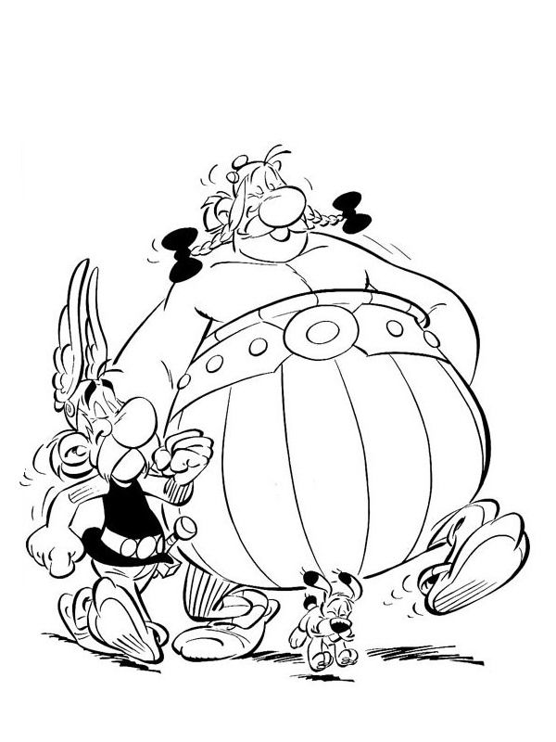**USPIO SI/ USPJELA STIGAO SI DO KRAJA, A ONDA ME MOŽEŠ OBOJATI AKO NIJE ZVONILO**

**Ej, ja mi smo živjeli u doba Rimljana tako kažu u crtiću, koji grad smo mogli posjetiti i tamo se okupati da smo zalutali u tvoj kraj? _____________________________________________.**