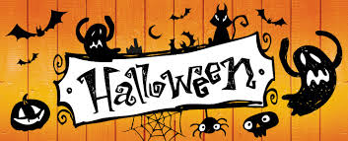

Go to: <https://www.youtube.com/watch?v=pw2PAAAKTO0>

Watch the video and answer the following questions:

1. When do people celebrate Halloween?
2. What does Halloween mean?
3. What Christian holiday comes after Halloween?
4. What did people in Europe believe about 31 October?
5. People dressed like ____________ to ___________ the ghosts.
6. ___________________ came from Europe to the USA and brought with them the custom of Halloween.
7. What do people put in the windows?
8. What do children get when they go trick-or-treating?
9. What do they do if they don't get treats?