**ODREDI ROD IMENICAMA!**

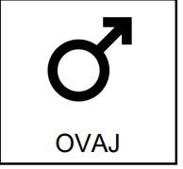 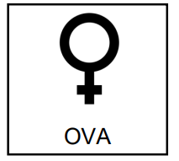 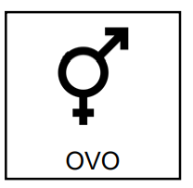

MUŠKI ROD ŽENSKI ROD SREDNJI ROD

(M) (Ž) (S)

**ŠTO VIDIŠ NA SLICI?**

**ODREDI ROD I NA CRTU UPIŠI M, Ž ILI S.**

JABUKA KRUŠKA AUTOMOBIL KREVET

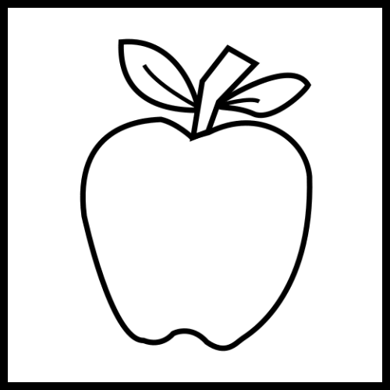 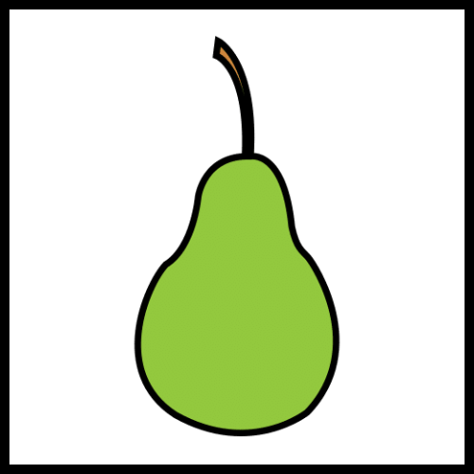 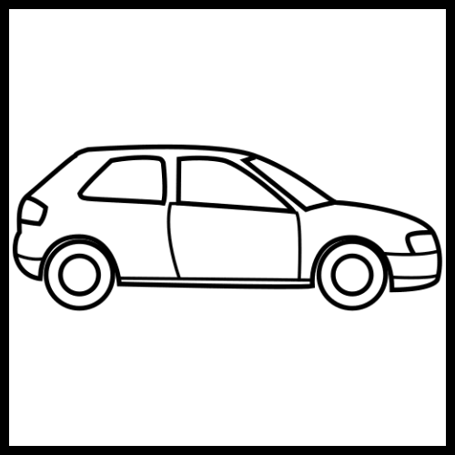 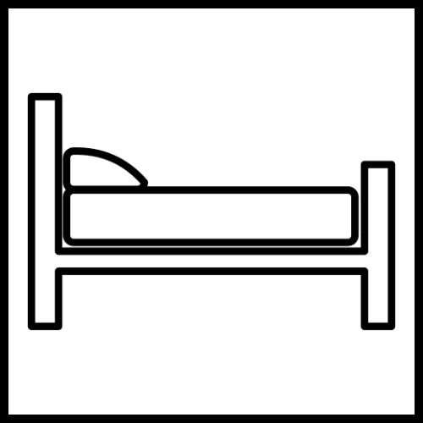

________ __________ _________ _________

STOL ŠKOLA DIJETE DRVO

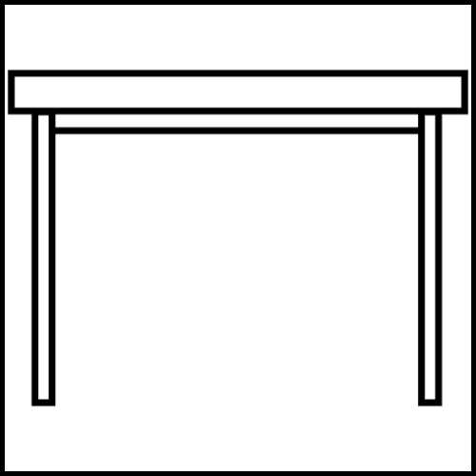 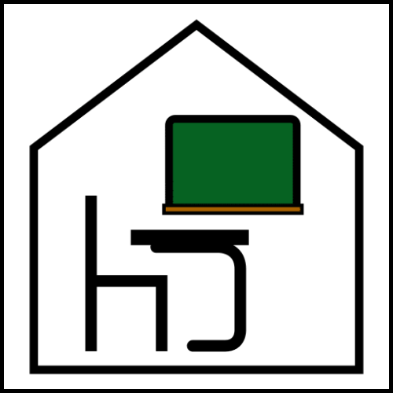 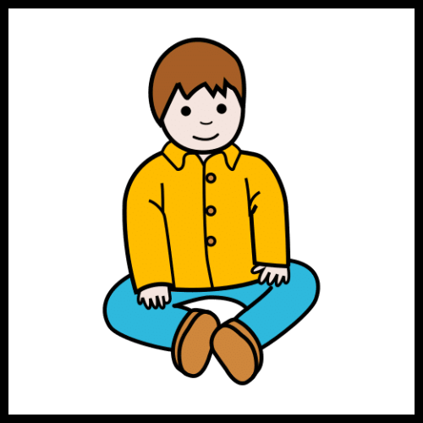 

________ _________ _________ _________

MAMA TATA DJED BAKA

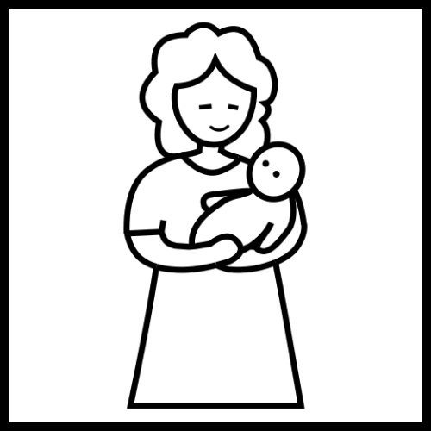  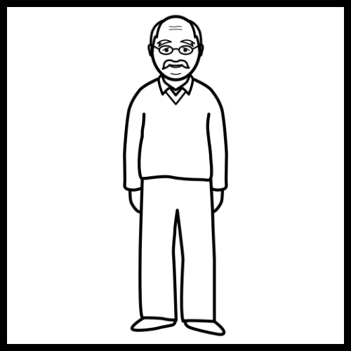 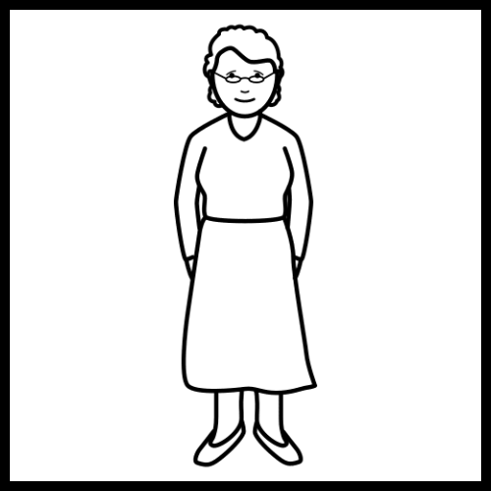

________ _________ _________ _________

OBLAK OLOVKA ŠILJILO KNJIGA



   