**PRIDJEVI**

RIJEČI KOJE OPISUJU **IMENICU.**

ODGOVARAJU NA PITANJA:

**KAKVO JE? ČIJE JE? OD ČEGA JE?**

BIJELO MAMINO DRVENO

CRNO TATINO LEDENO

ŠARENO BRUNINO METALNO

ZELENO LUKINO STAKLENO

PLAVO ŠKOLSKO CIGLENO

PRIDJEV IMENICA

PLAVO NEBO.

ŽUTO SUNCE.

ZELENA TRAVA.

MAMINA TORBA.

ŠKOSLKO IGRALIŠTE.

DRVENA KLUPA.

PROMOTRI SLIKU. NAPIŠI **PRIDJEV.**

**KAKVO JE?**



____________________________________

(MEDVJED)

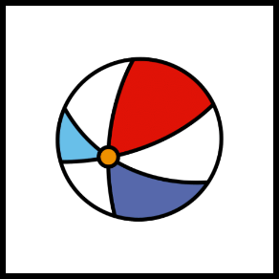

____________________________________

(LOPTA)

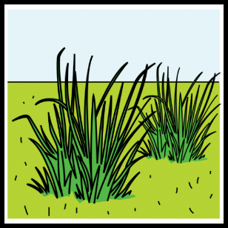

____________________________________

(TRAVA)

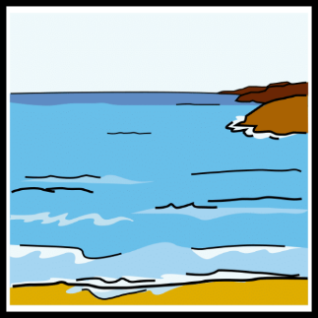

____________________________________

(MORE)



_____________________________________

(SOL)

PROMOTRI SLIKU. NAPIŠI **PRIDJEV.**

**ČIJE JE?**



____________________________________

(MAMA)

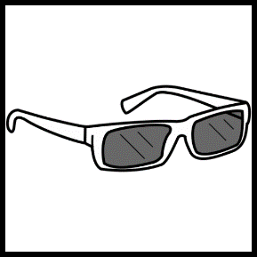

____________________________________

(ANA)

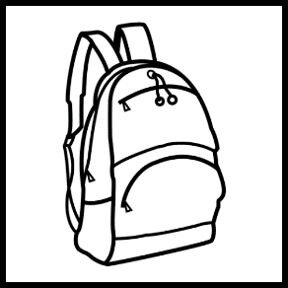

____________________________________

(LANA)



____________________________________

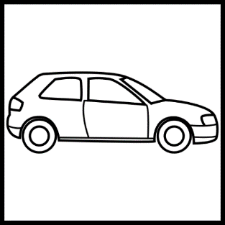(BAKA)

____________________________________

(TATA)

PROMOTRI SLIKU. NAPIŠI **PRIDJEV.**

**OD ČEGA JE?**

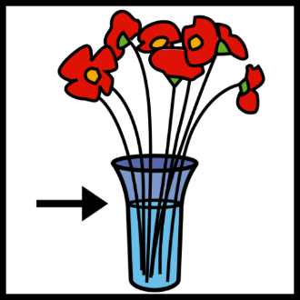

(STAKLO)

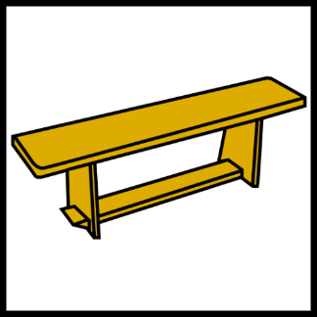

____________________________________

(DRVO)



____________________________________

(CIGLA)



____________________________________

(METAL)

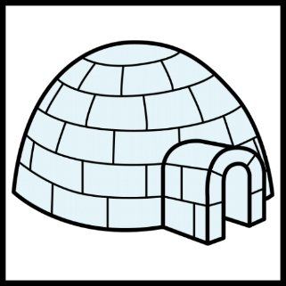

____________________________________

(LED)

PREPOZNAJEM PRIDJEVE.

ZAOKRUŽI KAKO SE OSJEĆAŠ.

