Lesson plan- primary pupils | Encouraging empathy through storytelling
English language | Duration: 90 min
Topic: Celebrating International Dot Day | Pupil's age: 9-10 years
Objectives : | - povezuje izgovorene riječi ili zvučni zapis riječi sa slikovnim prikazima i predmetima  – povezuje izgovorene upute ili zvučni zapis uputa s radnjama  – odgovara na pitanja razumijevanja (yes, no)  - neverbalno i verbalno pokazuje razumijevanje osnovne poruke teksta (odgovara na pitanja razumijevanja, pokazuje slikovnu karticu i slično)  – koristi se osnovnim strategijama za poboljšanje razumijevanja pri slušanju i čitanju  – izražava se različitim vrstama pokreta (mimika, geste, ples)  osr A.2.1.  Razvija sliku o sebi.  osr A.2.2.  Upravlja emocijama i ponašanjem.  osr B.2.4.  Suradnički uči i radi u timu.  ikt A.2.3.  Učenik se odgovorno i sigurno koristi programima i uređajima.  uku A.2.3.  Učenik se koristi kreativnošću za oblikovanje svojih ideja i pristupa rješavanju problema.
Lesson structure : | Activity 1: introducing the topic (6 min)  Ice -breaker: the guessing game  Look and guess, What am I drawing?  The teacher is drawing a big dot on the blacboard/whiteboard, the pupils are guessing the word  (possible answers: a circle, a ball, the Sun, The Moon, an orange,…). The teacher helps the pupils to guess the word: says or writes the first letter of the word, plays Hangman, or says the word _ _ _ rhymes with not, what, …  The teacher writes The Dot next to the drawing on the blackboard/whiteboard and introduces the topic of the lesson. We will listen and watch the story The Dot.  The teacher asks pupils:  Do you like stories?  What is your favourite story?  Activity 2: What do you think: what is the story The Dot about? (6 min)  The teacher can show flashcards to help pupils formulate their answers.    A TEACHER  (Pupils name the flashcards)  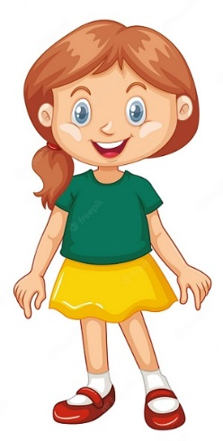  A GIRL  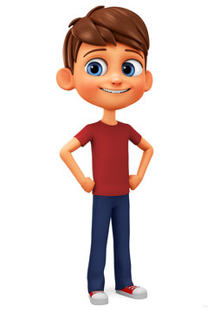 A BOY    A SCHOOL  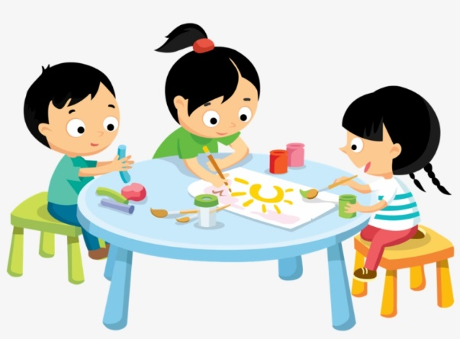  ART CLASS  The teacher introduces the story to the pupils: the story is about a girl Vashti. She is at school and she is having an Art class. Vashti doesn't like drawing at first but then, something happens…and it changes everything!  Let's listen and watch the story together!  Activity 3: pupils watch the video of the story(4 min)  https://www.youtube.com/watch?v=EpmNXbkLu6c  Activity 4: Learning Apps game, building the vocabulary  (8 min)  Adjectives describing a character:  https://learningapps.org/32091603  Scan the QR code to access the game on tablet/ mobile devices    Pupils play the game.  Activity 5: Worksheet, pupils write the adjectives describing Vashti at the beginning and at the end of the story  (8 min)  Vashti at the beginning of the story Vashti at the end of the story  ( angry, frustrated, nice, helpful, friendly, sad, upset, happy, creative)  key*  Vashti at the beginning of the story Vashti at the end of the story  angry nice  upset helpful  frustrated friendly  sad Happy  creative  Activity 6 : Second listening/watching the story  ( 10 min)  Pupils listen/watch the story one more time and in pairs put the sentences from the story in the correct order. The teacher needs to prepare slips of paper with sentences for pupils and distribute it in envelopes.  1. At first, Vashti thinks she can't draw.  2. She makes just a simple dot on her paper.  3. But her teacher tells her to sign her name below the dot.  4. Vashti discovers that the dot can be the start of something wonderful.  5. Vashti draws more dots and tries different colors and sizes.  6. Her dots become beautiful artworks.  Pupils read their sentences aloud and check the order of the events in the story.  Activity 7: Treasure Hunt ( 20 min)  The teacher prepares coloured paper circles with words/ sentence parts from task 6. Pupils walk around the calssroom and searc the coloured paper dots. When they find one, they read it and bring it to the blackboard to connect with other dots with the same colour. An example:  AT FIRST,  VASHTI  SHE CAN'T  THINKS  DRAW  Activity 7: Listening to the Dot Song and doing TPR  (8 min)  Before listening and doing TPR movements the teacher explains the pupils the meaning of a phrase Make a mark!  If pupils enjoy the activity repeat it one more time.  https://www.youtube.com/watch?v=r_I43cxDQ-o  Activity 8: Worksheet, Make your mark  (20 min)  The teacher prepares photocopies of a worksheet Make a mark and pupils draw their dots using colours.  The teacher can download the worksheet, here is the link: https://quivervision.com/coloring-packs/Celebrate-Dot-Day  Later, they can exhibit their art work around the classroom and they can grade each others work. Pupils can use simple table for peer evaluation.  Name of the pupil Great job!! Keep working! You can do it better!
Teaching forms/methods | Individual work, pair work, ex cathedra work ,speaking,listening,writing,reading using ICT ,presenting the project's work ,peer evaluation
21st century skills | Using ICT  Collaborative work -working in pairs  Critical thinking skills  Active use of English language  Creative thinking  Problem solving skills
Teacher : | Ivana Hrastović Mandarić and Alenka Taslak

