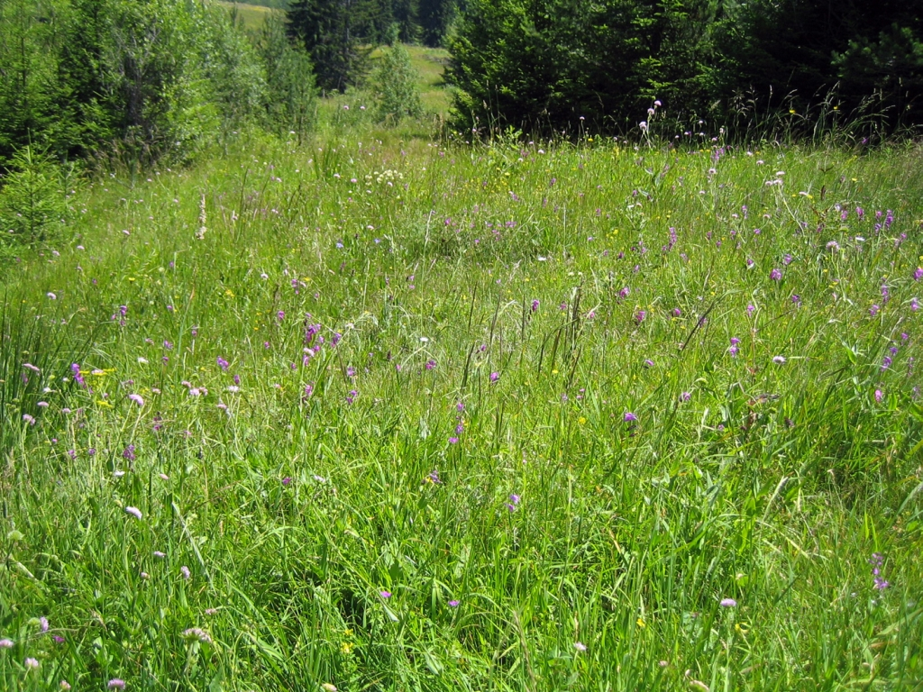 | 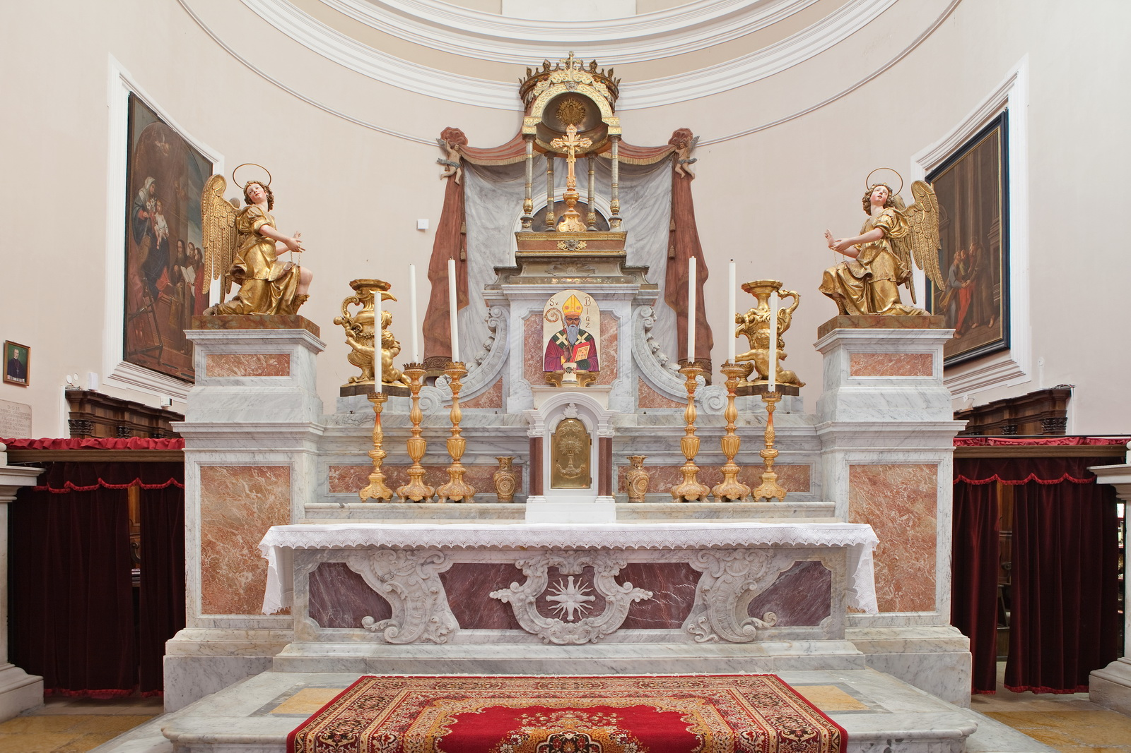 |  |  | 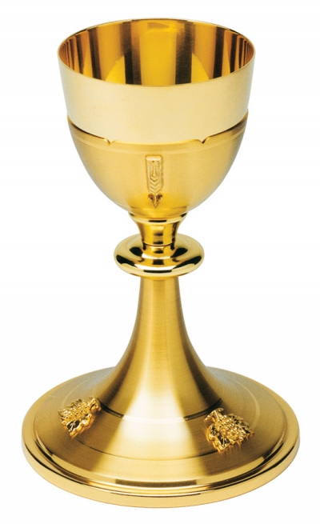
1 2 3 4 5 6 | 1 2 3 4 5 | 1 2 3 4 5 6 7 | 1 2 3 4 5 6 7 8 | 1 2 3 4 5
RJEŠENJE: ______________&______________________

1 2 3 4 5 6 | 1 2 3 4 5 | 1 2 3 4 5 6 7 | 1 2 3 4 5 6 7 8 | 1 2 3 4 5
RJEŠENJE: ______________&______________________

1 2 3 4 5 6 | 1 2 3 4 5 | 1 2 3 4 5 6 7 | 1 2 3 4 5 6 7 8 | 1 2 3 4 5
RJEŠENJE: ______________&______________________

