Recognizing and Expressing the Feelings

**1. Warm-Up**

- Greet the students and ask, "How are you feeling today?" Encourage them to use more descriptive words than "fine" or "good."

- Write some common emotional words on the board: happy, sad, angry, excited, scared, bored.

- Ask students: "How do you feel when...?" and give different scenarios (e.g., "How do you feel when it rains all day?", "How do you feel when you get a gift?", don't get an invitation to a birthday party, finish the homework all by themselves, win a competition, speak in front of the class).

- Introduce a few more specific emotion words like (choose which you find appropriate for the students' level of English): ***thrilled, frustrated, confused, joyful, worried, frustrated, irritated, nervous, annoyed, shocked, pleased, surprised, motivated, inspired, proud, calm, relaxed, satisfied, grateful, peaceful, tired, exhausted, disappointed, hopeless, pessimistic***.

Ask students to find synonms on the list for: happy, sad, angry, scared.

**2. Presentation**

- Present the words you have on the list in 1) for different emotions using pictures or cards, helping students associate emotions with facial expressions.

- Write each word on the board under two categories:

1. Positive Emotions: happy, excited, calm, joyful…

2. Negative Emotions: sad, angry, frustrated, scared, worried…

- For each word, ask a student to explain when they feel this emotion.

**3. Introduction to the Mood Meter**

- Draw a 4-quadrant Mood Meter on the board or show them the template:

(DON'T GIVE THEM THE WORDS, JUST THE PLEASANTNESS AND ENERGY GRAPH!)

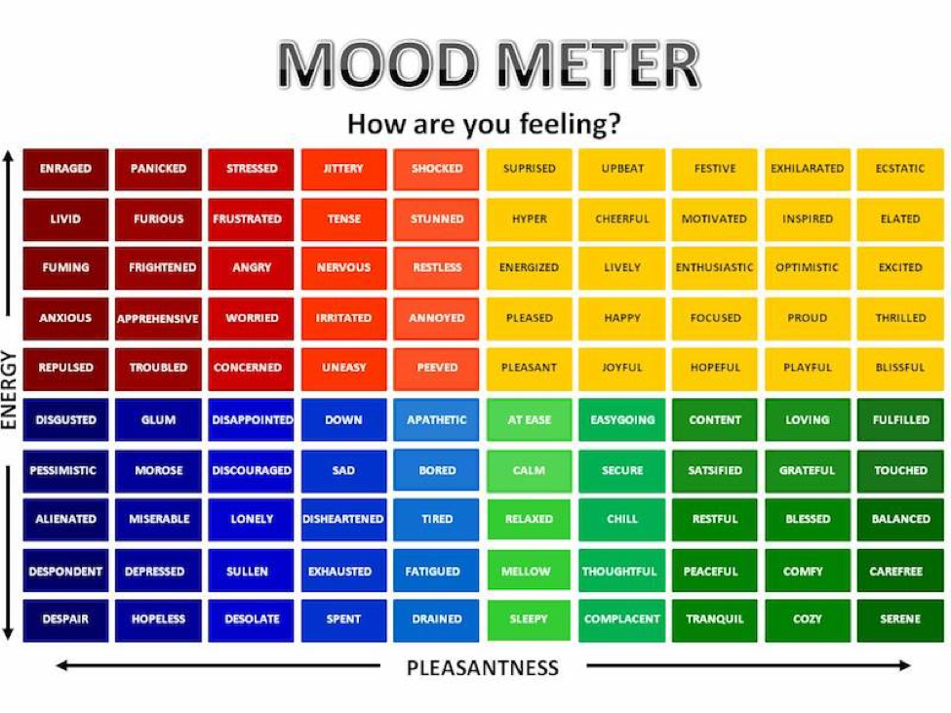

[Ta fotografija](https://profesoradoreligion.blogspot.com/2024/03/las-emociones-y-su-tratamiento-en-el.html) korisnika Nepoznat autor: licenca [CC BY-NC-ND](https://creativecommons.org/licenses/by-nc-nd/3.0/)

1. Upper Left (High Energy, Negative Feeling) – (e.g., Angry, Frustrated)

2. Upper Right (High Energy, Positive Feeling) – (e.g., Excited, Thrilled)

3. Lower Left (Low Energy, Negative Feeling) – (e.g., Sad, Tired)

4. Lower Right (Low Energy, Positive Feeling) – (e.g., Calm, Satisfied)

- Explain each quadrant:

- Emotions in the upper quadrants are stronger and more intense (high energy).

- Emotions in the lower quadrants are calmer and less intense (low energy).

- Emotions on the left are negative; those on the right are positive.

- Use the emotion words on the board and ask students where they would place them on the mood meter. Create a Mood Meter Poster in colour to display it in the classroom and have for further use.

**4. Guided Practice**

- Give students a set of situations (e.g., "Your friend forgot your birthday," "You got an A on your test," "You missed your bus", “The task on today’s English lesson”…), and ask them to point the corresponding emotion on the mood meter.

- Encourage students to explain their choices in simple sentences: "I feel happy when I get an A because it makes me proud." or "I feel angry when someone forgets my birthday because I feel unimportant."

**5. Techniques to Deal with Emotions**

- Ask students to share their techniques for calming or activating. It can be: listening to music, spending time with friends, sleeping.

- Students make sentences like: When I feel angry I talk about the problem with my mum. / When I feel excited I share the news with my friend. / When I feel motivated I help others to be successful. / When I am tired I go to sleep or take a nap.

**6. Teach Them Some Mindfulness Activities**

Ideas: Breathe like the belly is a balloon, Breathe like a snake, Count 5 things you can see and hear in this very moment (Countdown to calm), Say a positive sentence: Today I am going to be…, Tapping like it is raining on your head, Dancing…