**1.PREMA SLIKAMA DOPUNI REČENICE RIJEČIMA.**

U VRTU RASTE _________________________ .

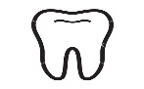ZUBAR JE ZVONKU POPRAVIO _________________ .

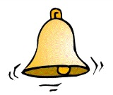NA ZVONIKU JE _____________________ .

**2.POVEŽI DIJELOVE REČENICA.**

PUŽ POLAKO JE ŽABA.

ŽUNA JE PUZI.

U VODI NA STABLU.

**3.STAVI ZNAK NA KRAJU REČENICE.**

Pazi,mačka

U šumi je zec

Gdje je Marko

Iva lijepo piše

**4.SLOŽI REČENICE.PREPIŠI IH VELIKIM TISKANIM SLOVIMA.**

Božena? juri Kamo

___________________________________________________________________

kino. u Žuri

____________________________________________________________________

jede kupus? Tko

_____________________________________________________________________

jede Zec kupus.

_____________________________________________________________________